Sr. No | Name of Alumni | Designation | Name of the Company | Testimonials | Photos
1 | P.Ramaswamy | Head -Insurance Business | NSEIT | I would like to highlight the thoughts, values and ideas that inspired me to win hearts, due to the grooming that I received from BVIMSR. | 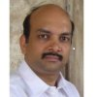
2 | Shashikant Pawar | Senior Manager | Glenmark Pharma | I enjoyed the very open minded and rich interactions with the classmates and faculties during my MMS at BVIMSR
3 | Umang Parmar | Vice President | HSBC Ltd | "BVIMSR is a magnificent mosaic of various culture abundant knowledge, great friendship and unforgettable memories. BVIMSR provided me with lessons in management as well as in corporate excellence. "
4 | Vishal V Gorad | Asst. Manager (Sales) | Lnaxess India Pvt.Ltd | "The MMS programme of BVIMSR has helped me in expanding my career possibilities by giving me specialized knowledge and skills to apply it to my career goals."
5 | Divya Agrawal | Assistant Manager | Human Tree | "At BVIMSR I got an opportunity to build my personal and professional skills. It has helped me to develop a positive attitude towards discovering more about myself. | 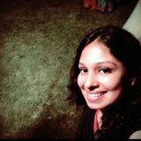
6 | Arya K | Business Development Manager | IFB Shipping India Pvt.Ltd | "Investing 2 years in BVIMSR for doing my masters has been one of my major life changing decisions. | 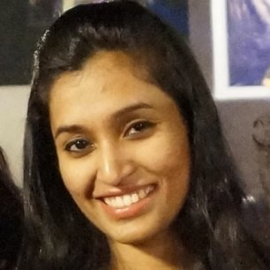
7 | Anand Thakkar | Executive (Operations) | ICICI Securities | BVIMSR offers a blend of learning, amusement and integration of enduring principles which enhanced my overall personality and fuelled confidence in me. | 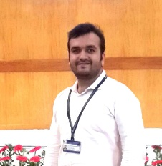
8 | Gaurav Chauhan | Management Trainee | ITC Ltd | I feel privileged to be a student of BVIMSR “for taking the extra mile and in being coaches and mentors to all the students. | 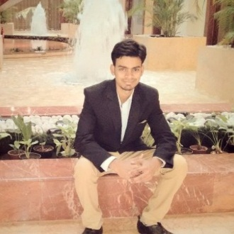
9 | Shalini Prasad | Business Development Manager | Zaro Education | I am proud to be alumnus of BVIMSR and realized how vital my education from BVIMSR is in today’s business world. | 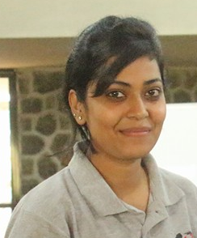
10 | Rahul Babar | Management Trainee | Future Group | "I appreciate the efforts and opportunities provided by BVIMSR which helped me in every sphere of my career and life.

